GRACE CHINESE GOSPEL CHURCH OF NORTH YORK

Doc # | Title | Rev.
P12 | Pastoral Counselling Policies, Guidelines and Code of Ethics | A

LIST OF REVISIONS
Section | Description of Changes | Rev. | Date  (mmm dd, yyyy) | Reviser
N/A | Original | Orig. | N/A | Unknown
N/A | Standardization and Centralization of GCGCNY Policies and Procedures | A | Nov. xx, 2012 | A. Cheung

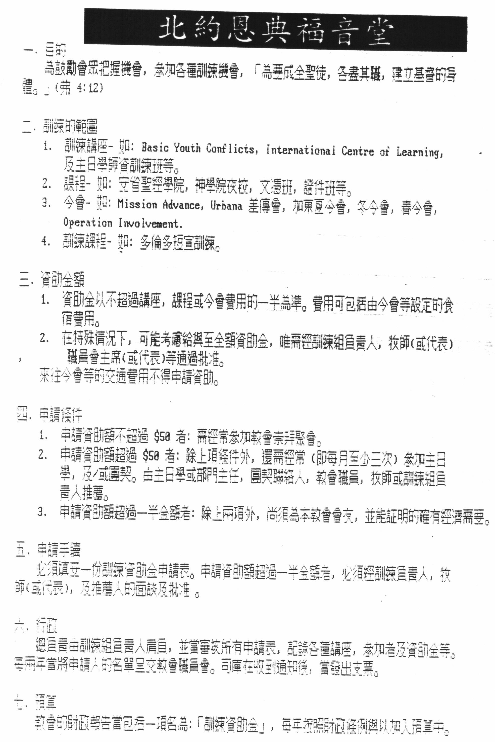

Grace Chinese Gospel Church of North York

Training Subsidy Application Form (02/15/06)
北 約 恩 典 福 音 堂 – 訓 練 資 助 申 請 表

Applicant’s Information/申 請 人 資 料

Last Name/姓氏: ___________________ First Name/名字: ______________________

Fellowship/Cell/所屬團契/小組: __________________ Years in the Cell/Fellowship參與團契/小組年日: _______

Number of Years in GCGC/參與恩典堂年日: _________ Member?/是否會友: yes/是; since從 ______年

Course / Conference Name/課程/會議名稱: _________________________________________________

Organized by/舉辦機構: _________________________________

Date of Course / Conference課程/會議日期: _______________________

Reason for attending/參加原因: ______________________________________________________

Total Cost/費用: ____________________________________

Total Subsidy applied/申請資助費用: ___________________

___________________________ _________________________
Signature/簽署 Date/日期

Applicant after filling the form above, please hand in to your ministry supervisor for approval. The amount if approved depends on a number of factors: budget left, helpfulness of the course/conference to the applicant and the church.
申請人請在填妥表格後將表格文於事工管理人作批准。資助費用會從以下數項作決定：剩餘預算、課程/會議對申請人及教會的幫助，等等。

Ministry Supervisor Approval/事工管理人批准

Last Name/姓氏: _______________________ First Name/名字: _______________________________

Ministry Department/事工部門: __________________________________________________________

Approved?批准?: 是yes 否no Approved Amount of Subsidy/批准資助費用:_____________________

Reason if amount not matched with that applied/批准及申請資助費用不同的原因:__________________________

______________________________________________________________________________________________

____________________________ ____________________________
Signature/簽署 Date/日期

Date of Board Meeting or Membership Meeting approving the change(s).

